API Operation Staging Table Setting Examples

Example 1: A table links to json result child level node.
As the screenshot below, if we want to store the data array in json array node “response.data” in a single table “response__data”.
Step 1, generate default json schema datamap mapping.
Step 2, edit the schema dataset mapping, in userdefines section, set root_type_name to “response”, which is the root node of the api json response.
Step 3, remove other tables’ options in userdefines section.
Step 4, Continue the Staging table setting steps, generate runtime schema, generate table and script, and then commit to run.

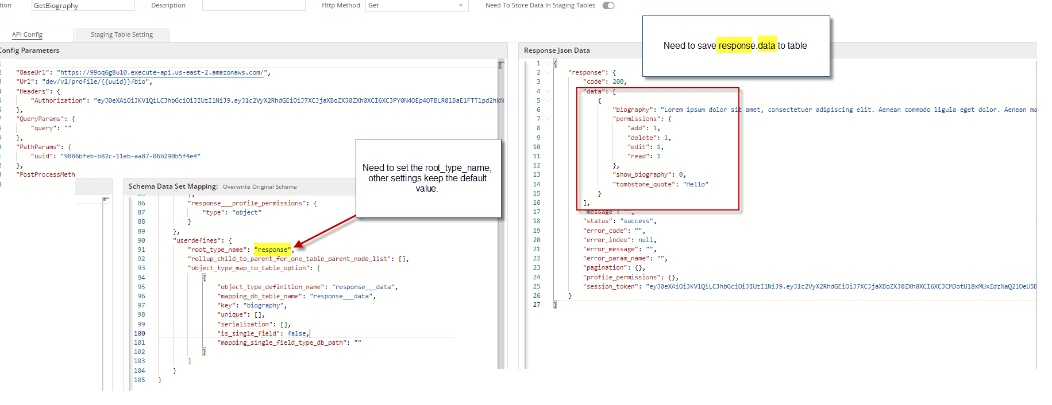

Example 2: If we don’t want to generate child tables for some child array nodes.

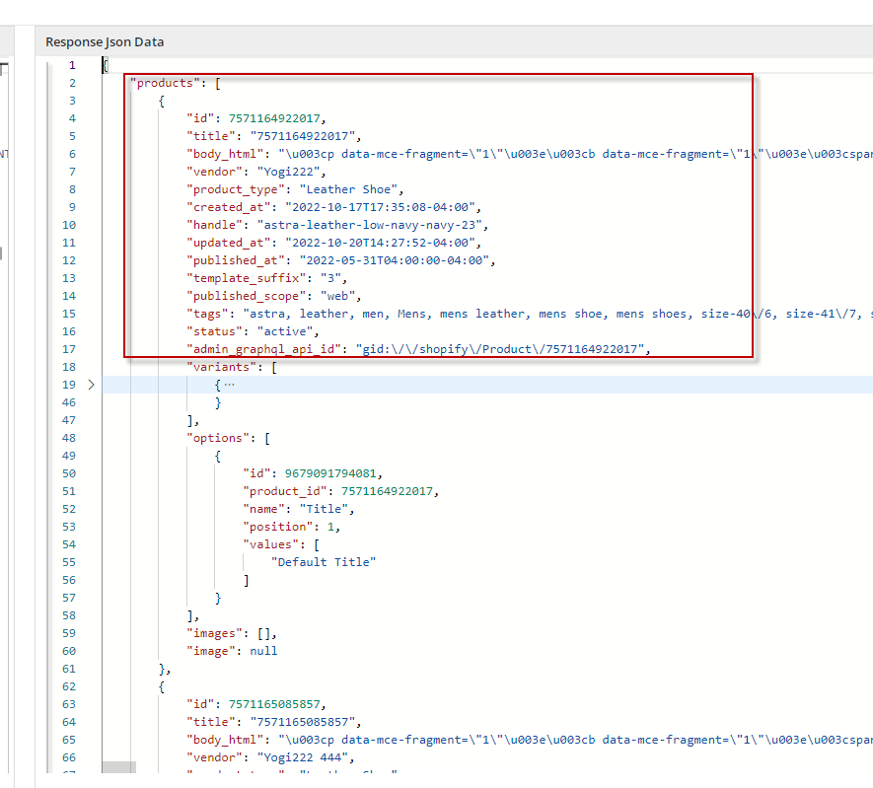
As the screenshot above, the json data contains an array of products, each product contains a variants array and an options array.By default, the system will generate 3 tables: products, products__variants, and products__options.
If we only want to generate one table for node "products, and ignore the child nodes: "variants" and "optoins".

The steps are below:

Step 1. Remove Node from definition.

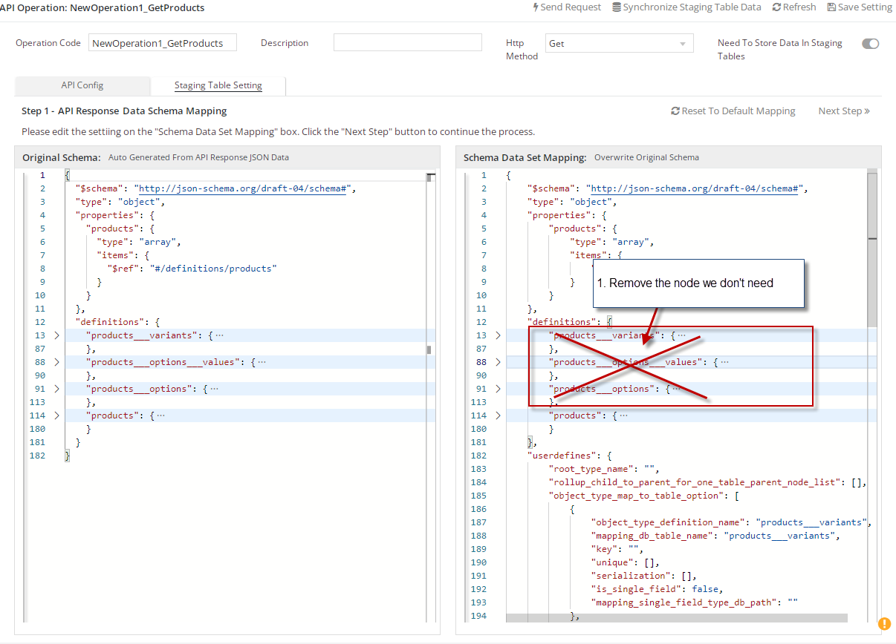

Step2. Remove the referenced properties.
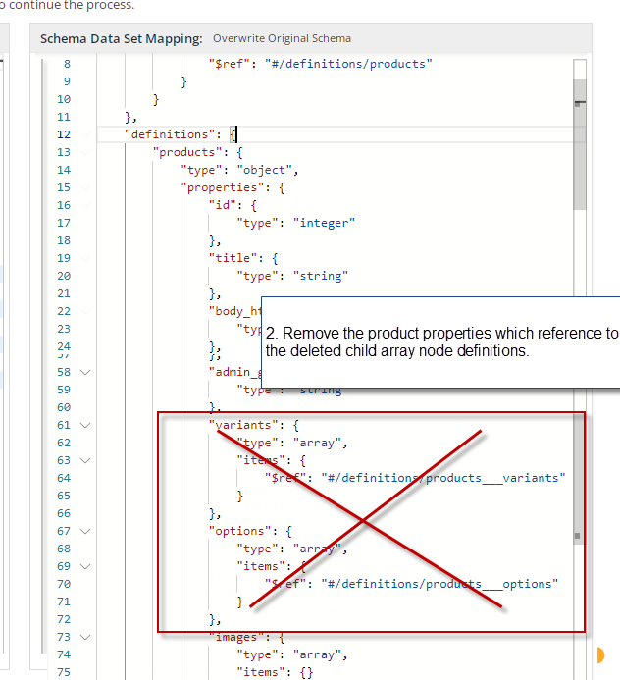

Step 3. Remove nodes from user defines section. Don’t forget to set the root_type_name.
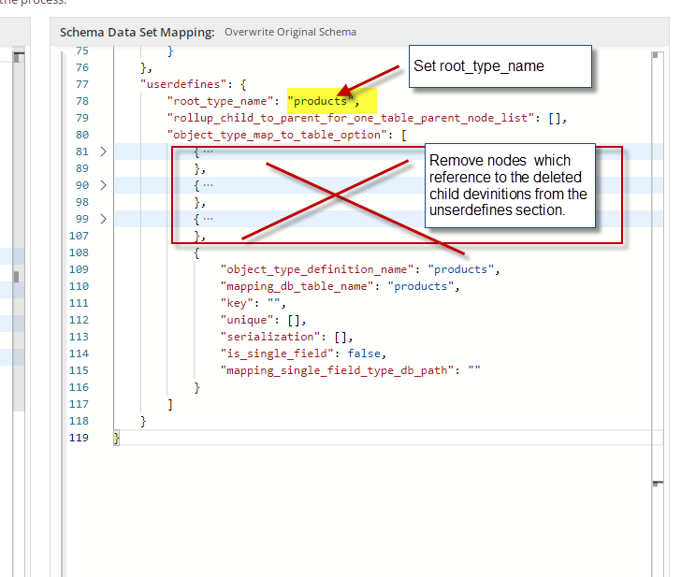

Step 4, Continue the Staging table setting steps, generate runtime schema, generate table and script, and then commit to run.

Example 3. Overwrite Table Column Type.

By default, the system will give default property type on the definition of node of JSON schema mapping.
If we want to overwrite the property type for staging table column creation, we can set it as below:
Add a format setting for the property.

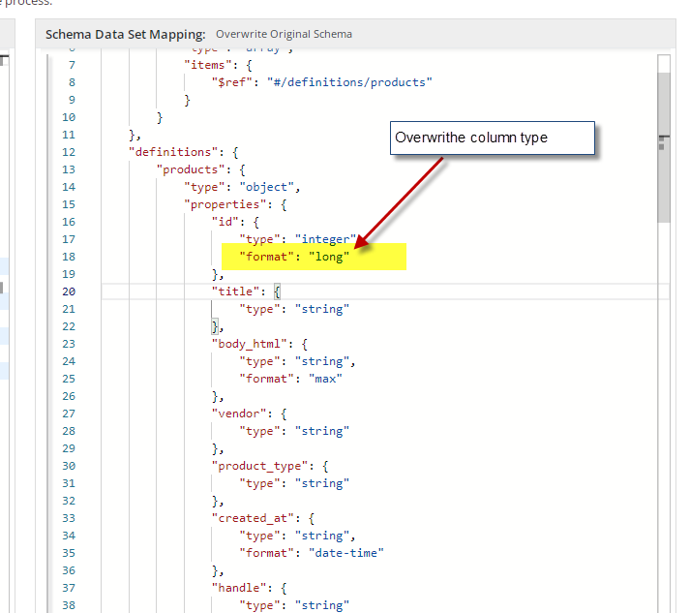

The format list:
public static class JsonFormatStrings
{
/// <summary>Format for a <see cref="System.DateTime"/>. </summary>
public const string DateTime = "date-time";

/// <summary>Non-standard Format for a duration (time span)<see cref="TimeSpan"/>. </summary>
public const string TimeSpan = "time-span";

/// <summary>Format for a duration (time span) as of 2019-09 <see cref="TimeSpan"/>. </summary>
public const string Duration = "duration";

/// <summary>Format for an email. </summary>
public const string Email = "email";

/// <summary>Format for an URI. </summary>
public const string Uri = "uri";

/// <summary>Format for an GUID. </summary>
public const string Guid = "guid";

/// <summary>Format for an UUID (same as GUID). </summary>
[Obsolete("Now made redundant. Use \"guid\" instead.")]
public const string Uuid = "uuid";

/// <summary>Format for an integer. </summary>
public const string Integer = "int32";

/// <summary>Format for a long integer. </summary>
public const string Long = "int64";

/// <summary>Format for a double number. </summary>
public const string Double = "double";

/// <summary>Format for a float number. </summary>
public const string Float = "float";

/// <summary>Format for a decimal number. </summary>
public const string Decimal = "decimal";

/// <summary>Format for an IP v4 address. </summary>
public const string IpV4 = "ipv4";

/// <summary>Format for an IP v6 address. </summary>
public const string IpV6 = "ipv6";

/// <summary>Format for binary data encoded with Base64.</summary>
/// <remarks>Should not be used. Prefer using Byte property of <see cref="JsonFormatStrings"/></remarks>
[Obsolete("Now made redundant. Use \"byte\" instead.")]
public const string Base64 = "base64";

/// <summary>Format for a byte if used with numeric type or for base64 encoded value otherwise.</summary>
public const string Byte = "byte";

/// <summary>Format for a binary value.</summary>
public const string Binary = "binary";

/// <summary>Format for a hostname (DNS name).</summary>
public const string Hostname = "hostname";

/// <summary>Format for a phone number.</summary>
public const string Phone = "phone";

/// <summary>Format for a full date per RFC3339 Section 5.6.</summary>
public const string Date = "date";

/// <summary>Format for a full time per RFC3339 Section 5.6.</summary>
public const string Time = "time";
}

